SQL homework:-

I have created one database batch1169 and one table empdetails.

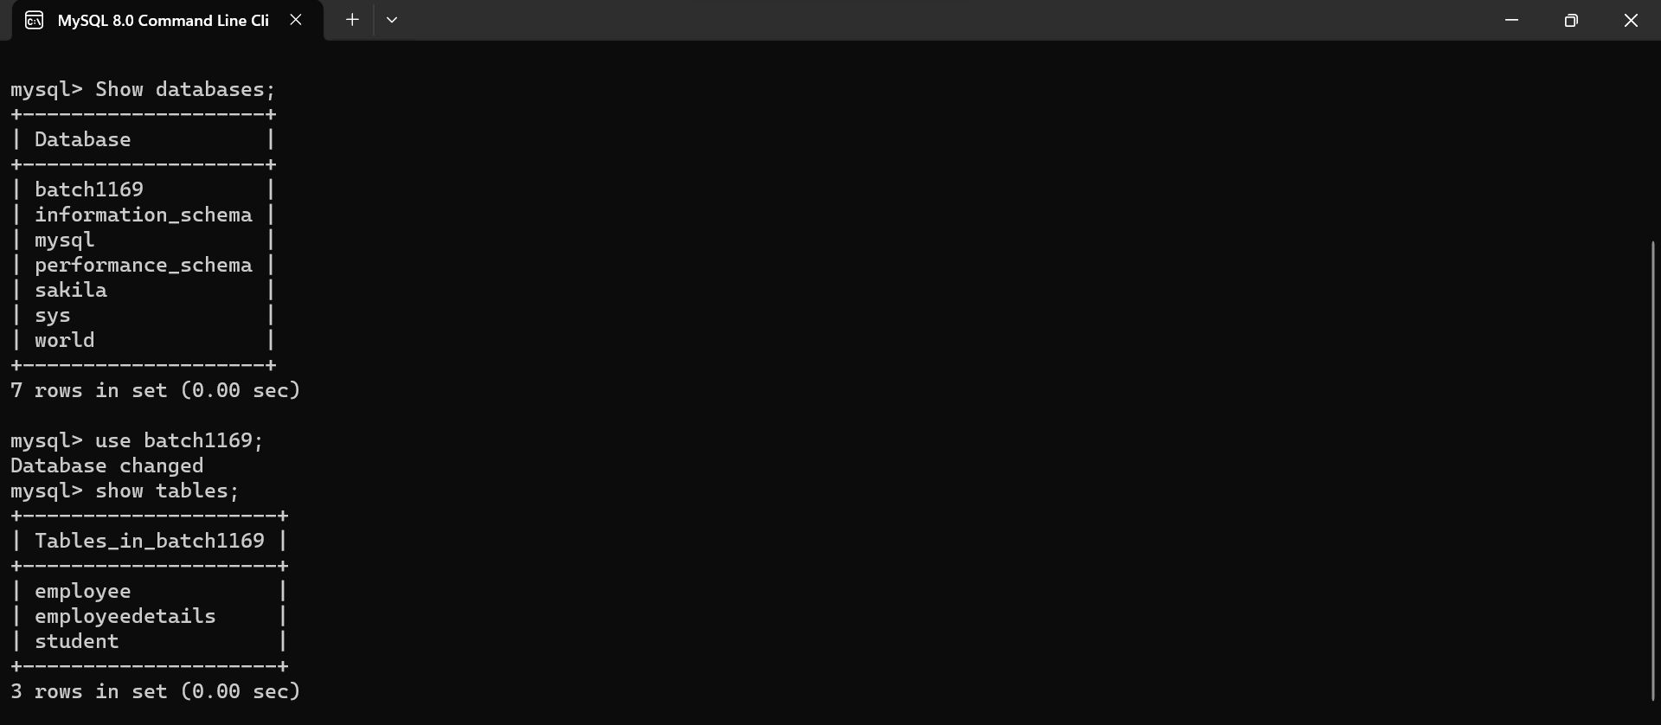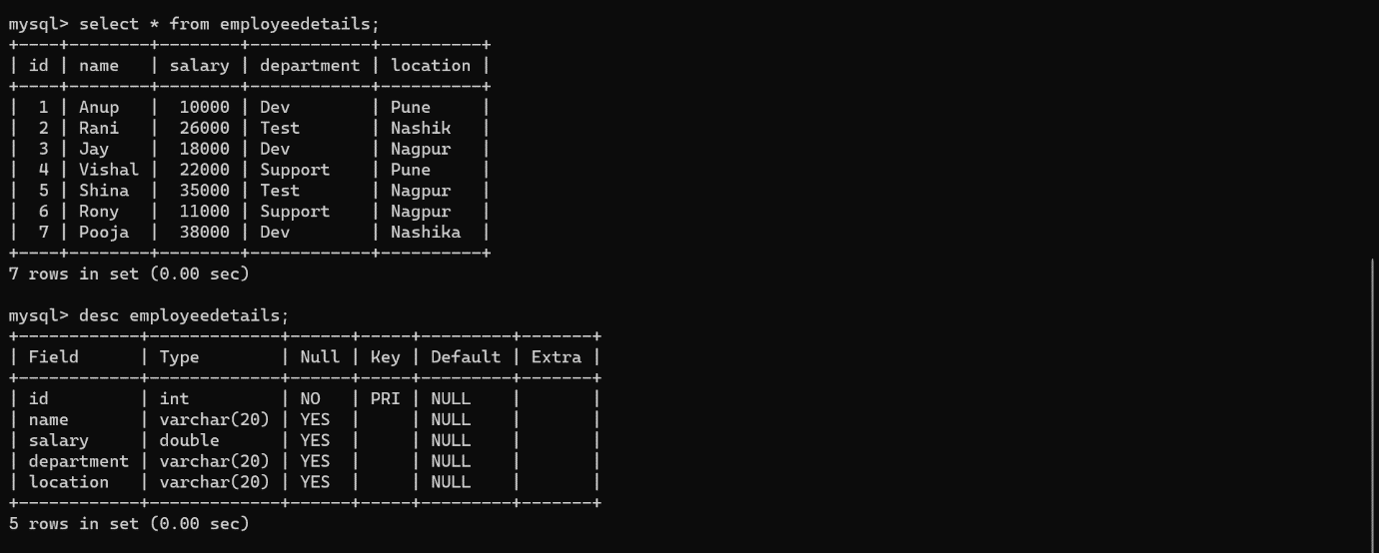1.What are the names of all employees?

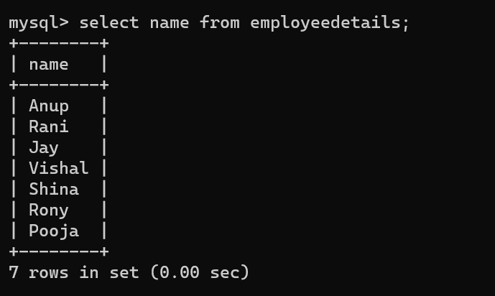

2. How many employees are there in total?

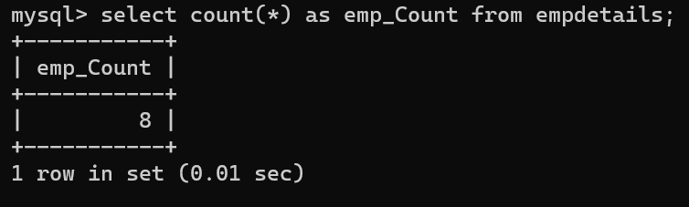

3. What departments do the employees work in?

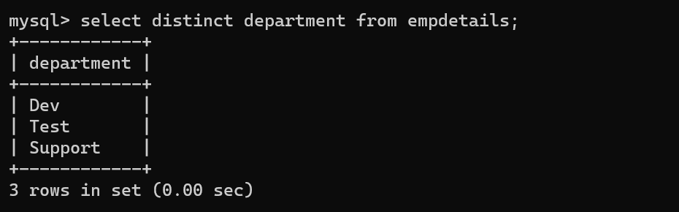

4. How many employees work in each department?

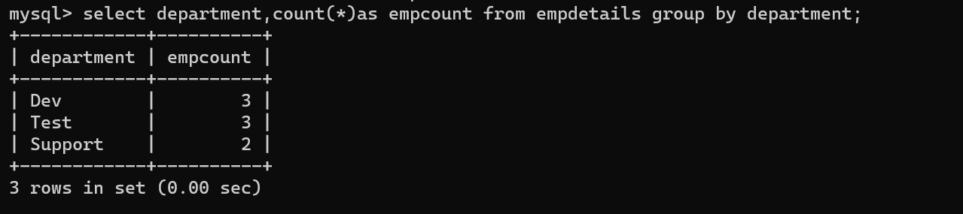

5. Who is the highest-paid employee?

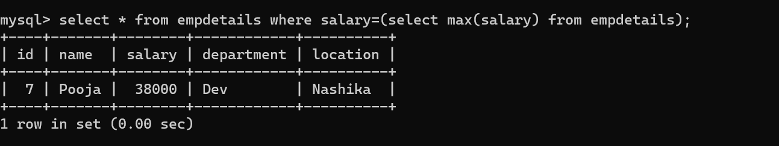

6. Who is the lowest-paid employee?

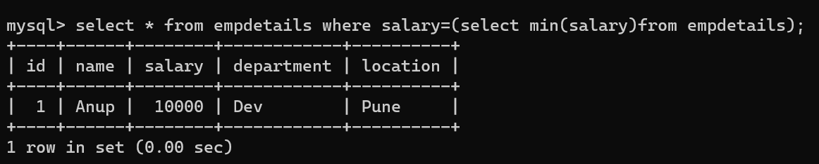

7. How many employees earn more than RS 20000 per year?

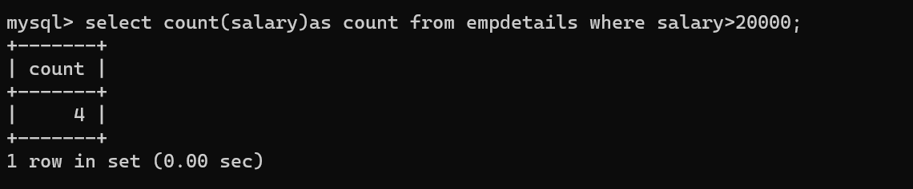

8. What is the average salary of all employees?

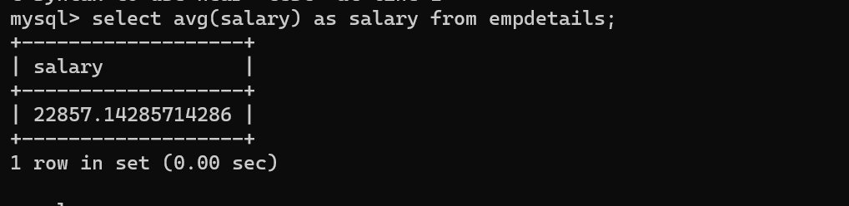

9. Who are the top 5 highest-paid employees?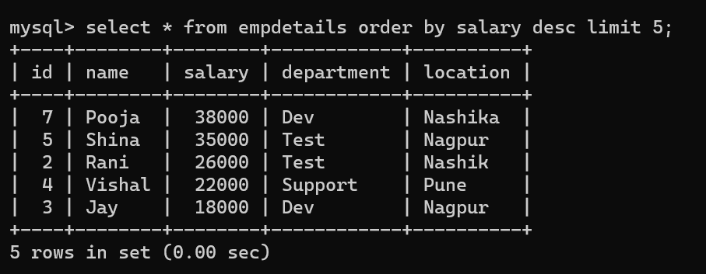

10. Who are the employees in the Test department?

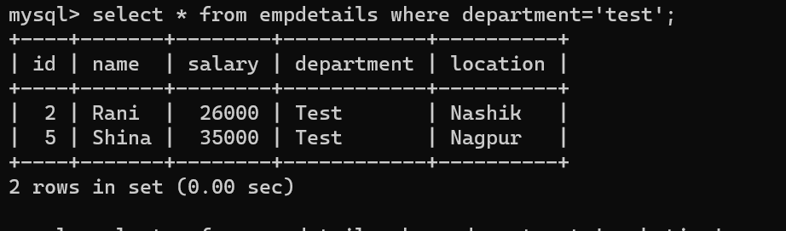

11. How many employees have a salary between RS 15000 and RS 25000?

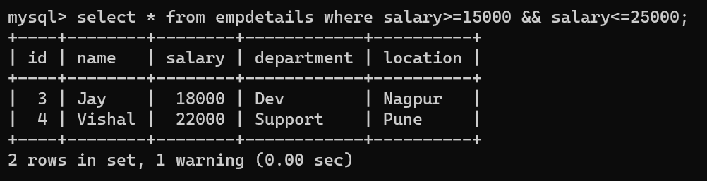

12. Who are the employees with a salary of NULL?

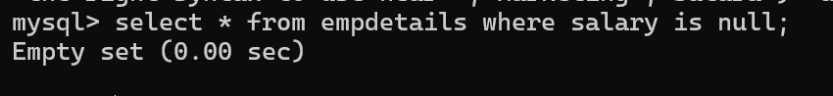

13. Who are the employees with a first name starting with "J"?

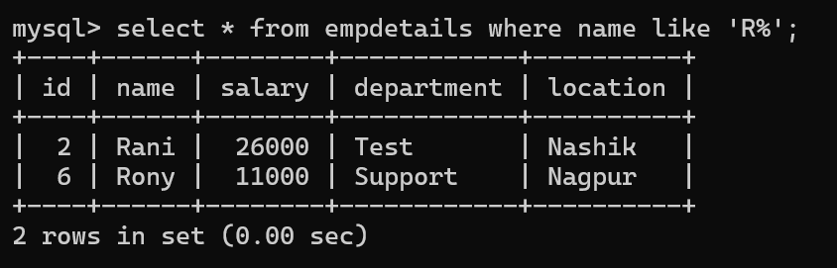

14. What are the salaries of all employees sorted in descending order?

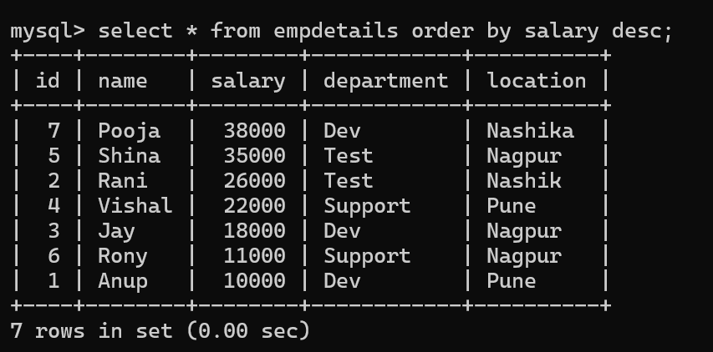

15. What is the total salary expenditure of the company?

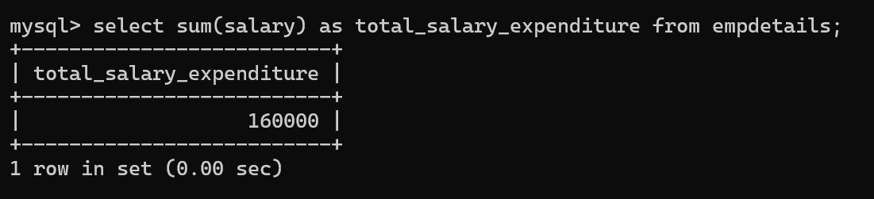

16. Who are the employees with the same first names?

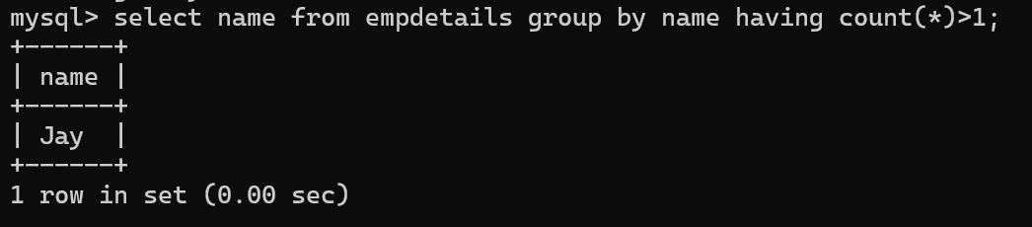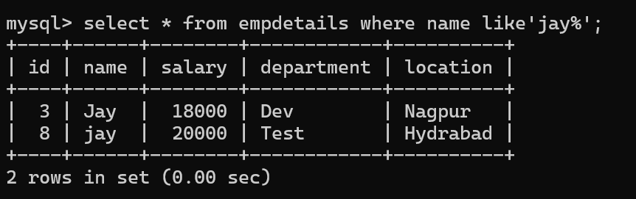

17. How many employees are there in Pune location?

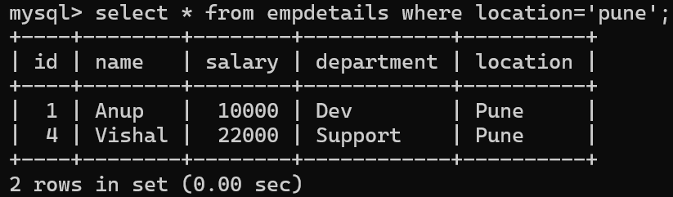

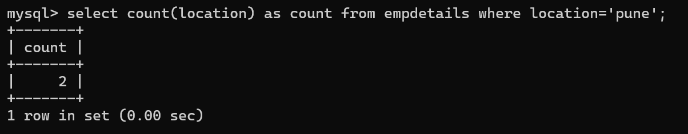

18. What is the average salary of employees in Dev department?

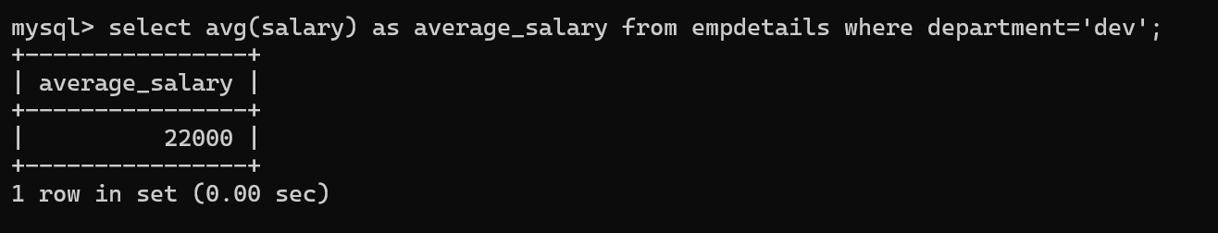

19. Who are the employees with salaries above the average?

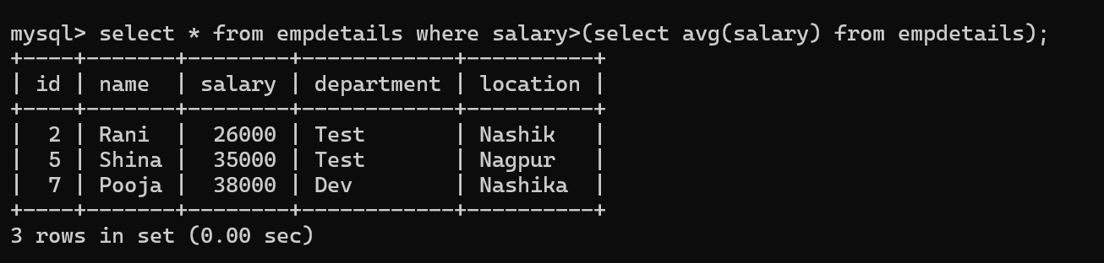

20. Who are the employees with the lowest salary in Test department?

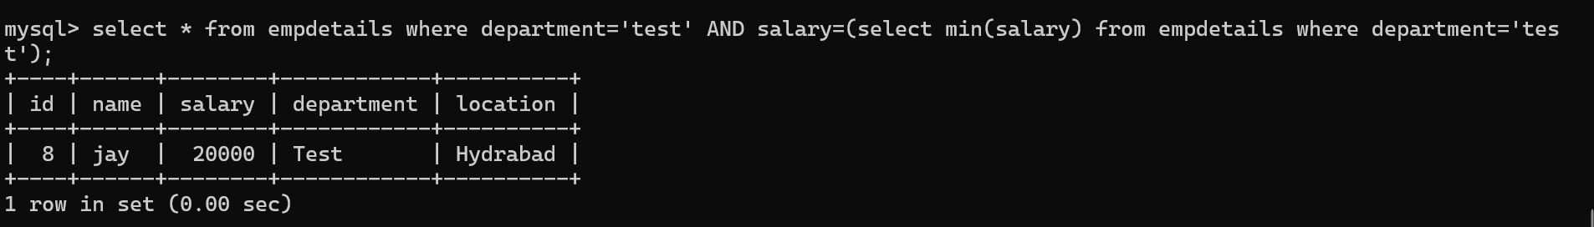

21. How many employees were hired in 2023 year?

22. Who are the employees hired in the year 2023?

23. What is the total salary expenditure in Dev and Support department?

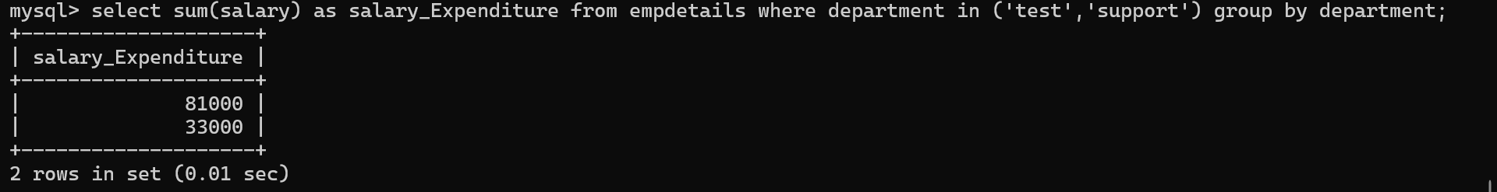

24. Who are the employees with a salary greater than the average salary of Dev department? 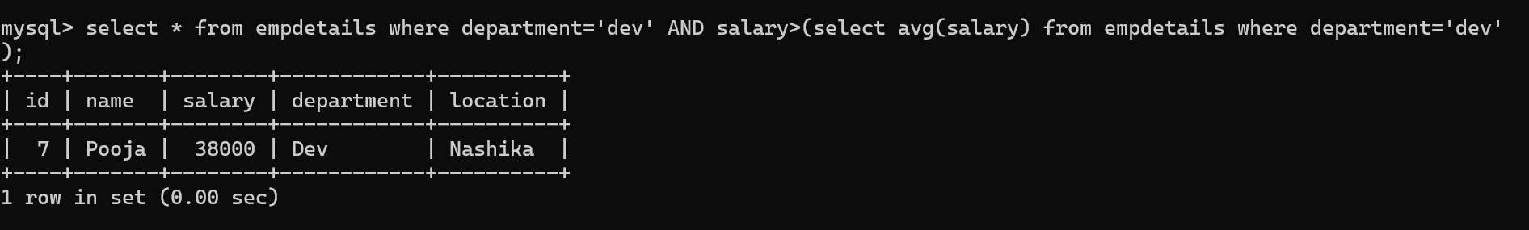

25. What is the total salary expenditure in Pune location?

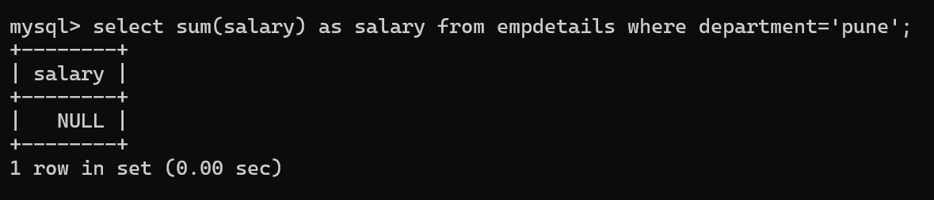

**26. Use of Logical and operator**

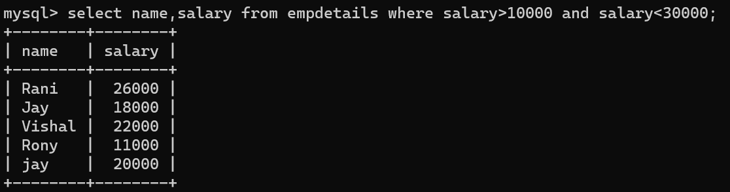

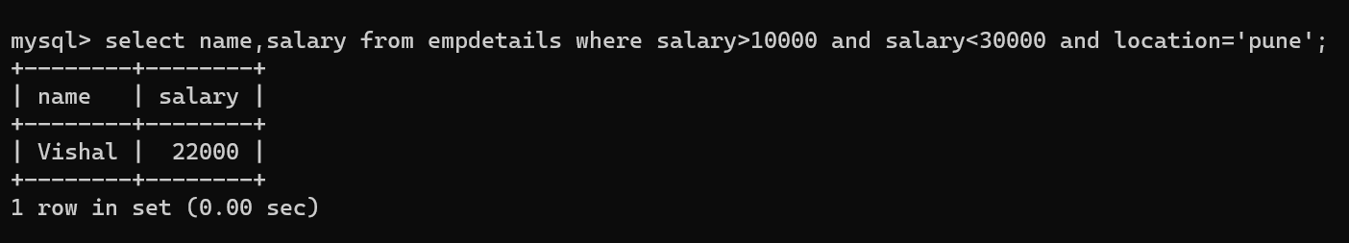

**27.Order by**

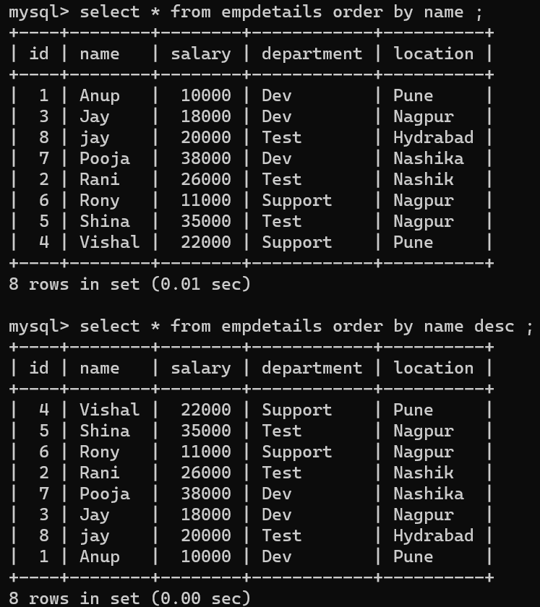

**28.Upper Lower String:-**

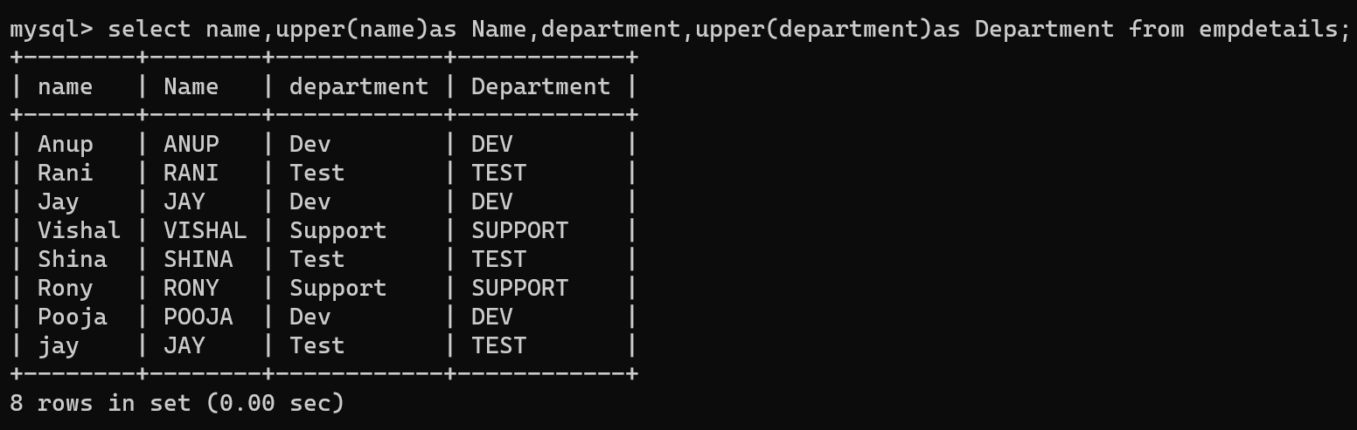

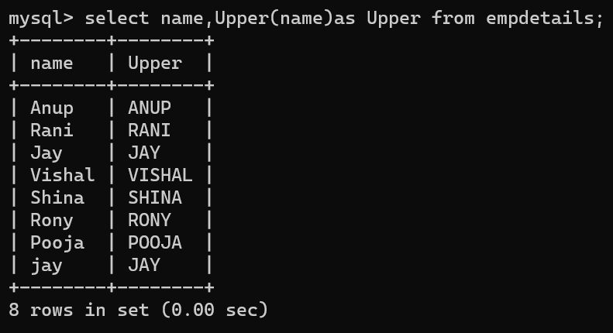

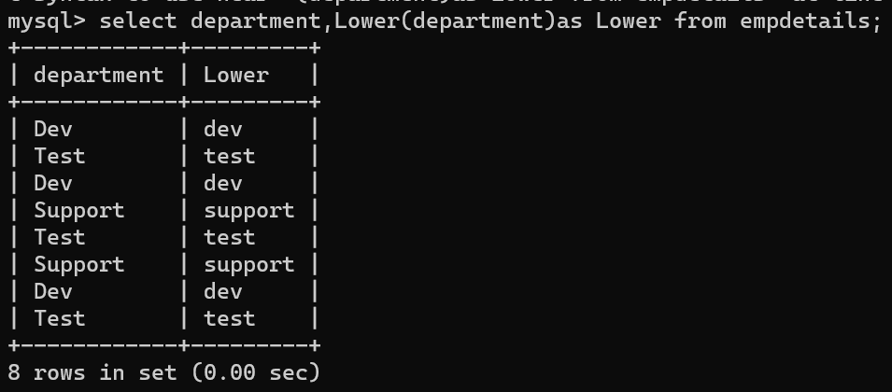

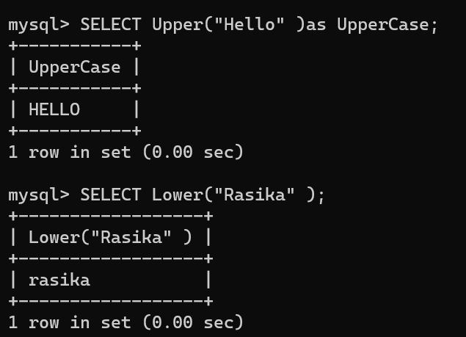

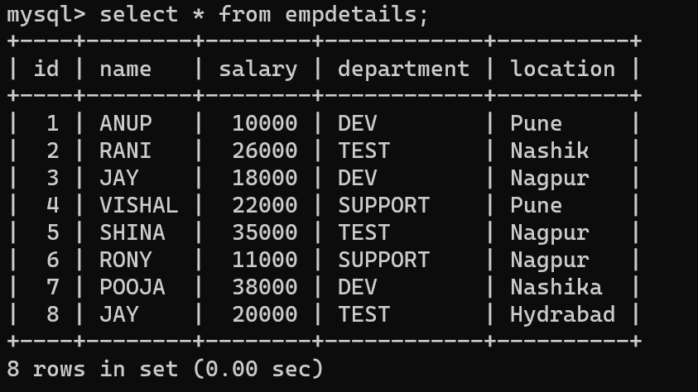

**29.Length:-** 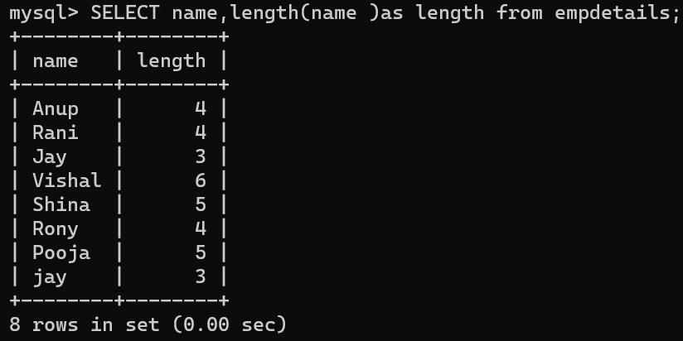

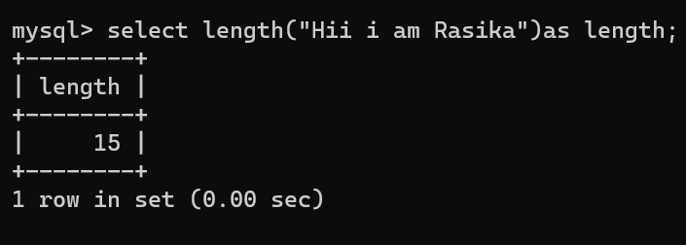

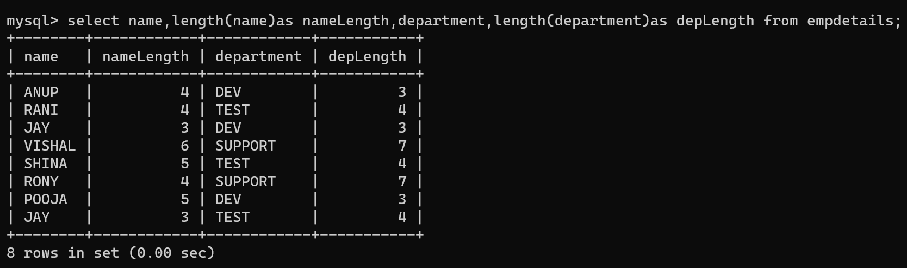

**30. SUBSTRING() or SUBSTR()**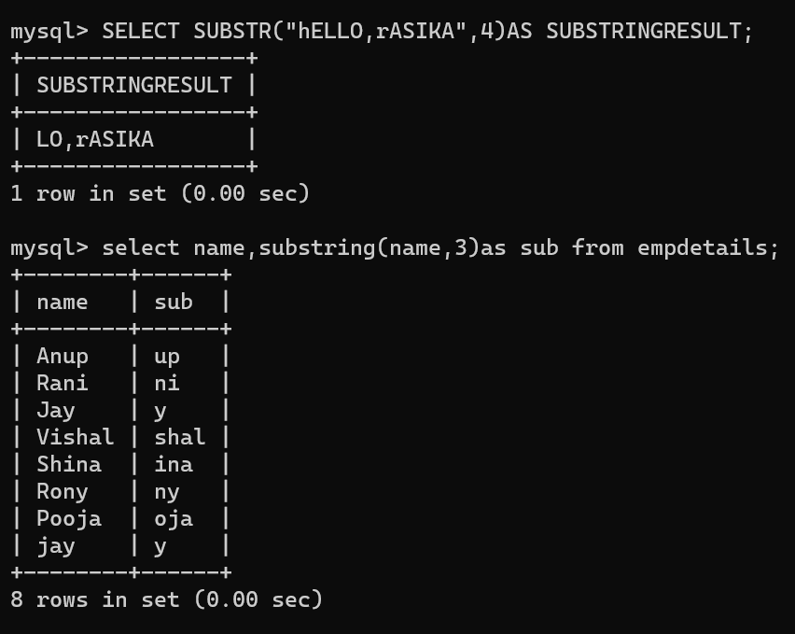

**31. CONCAT() or ||:-** 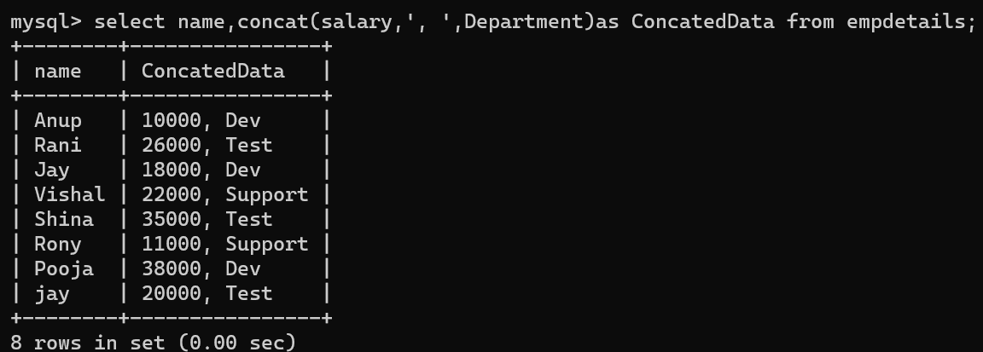

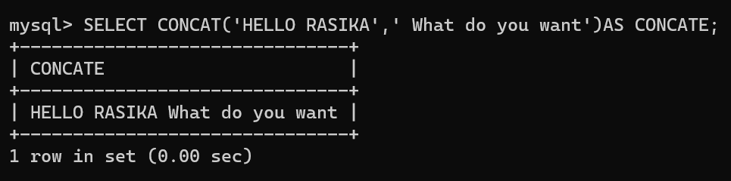

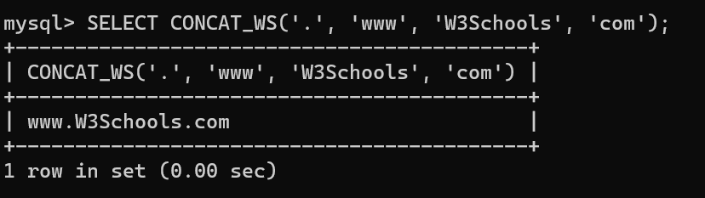

**32.Trim:-**

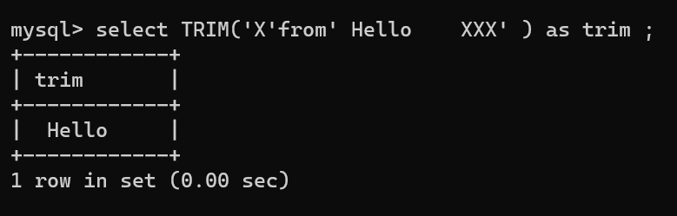

**33.Replace:-**

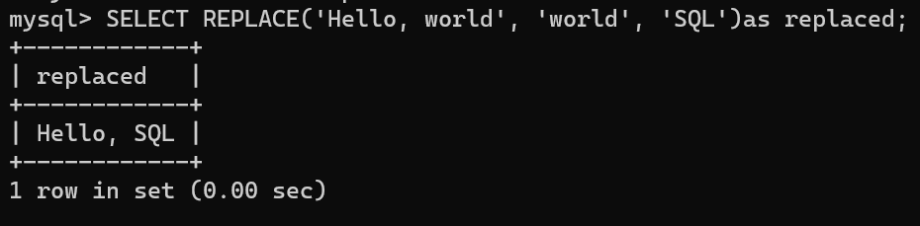

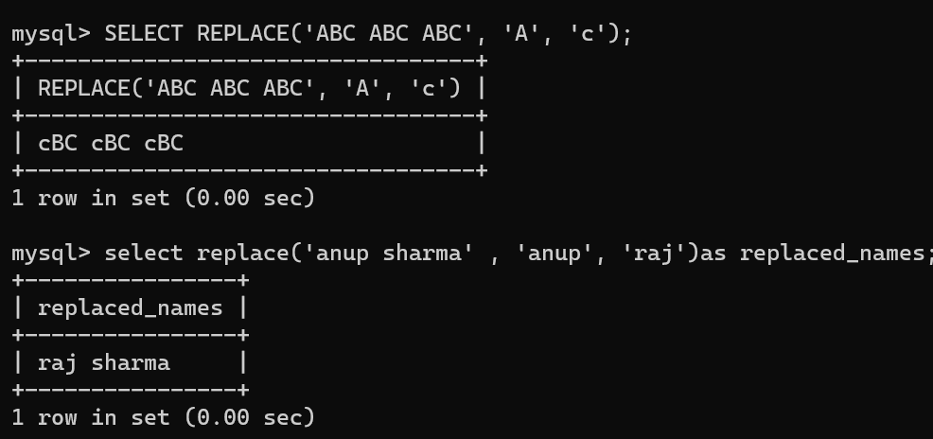

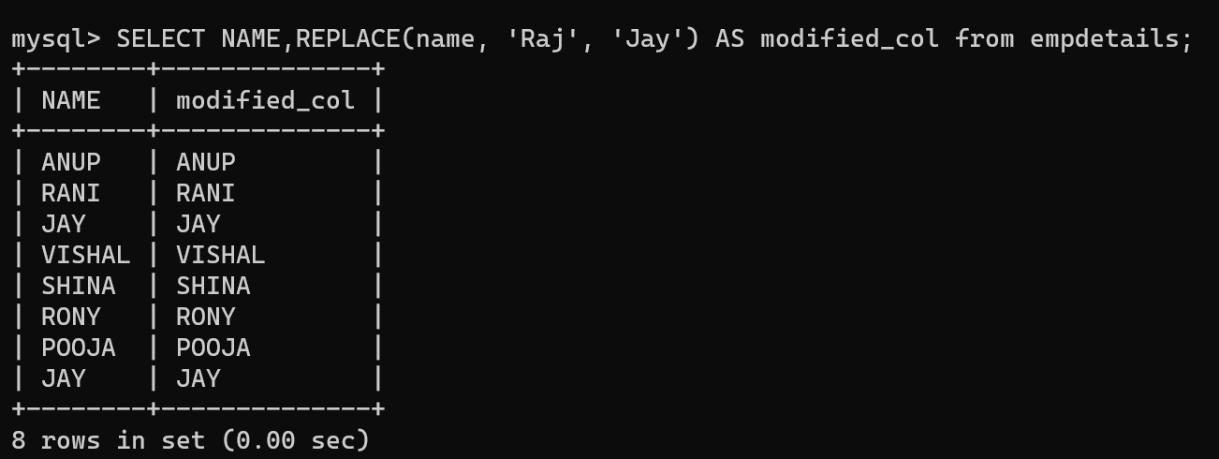

**34.Position:-** 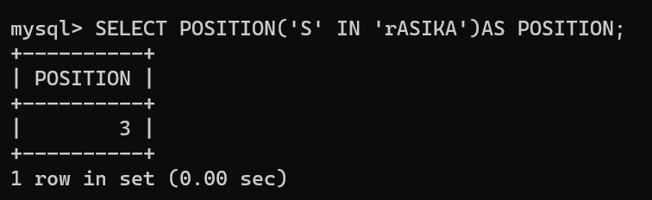

**35.Left or right character:-**

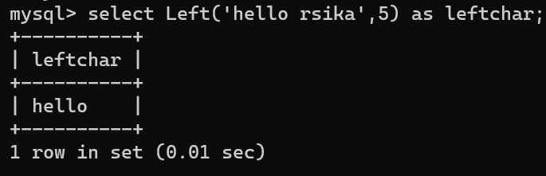

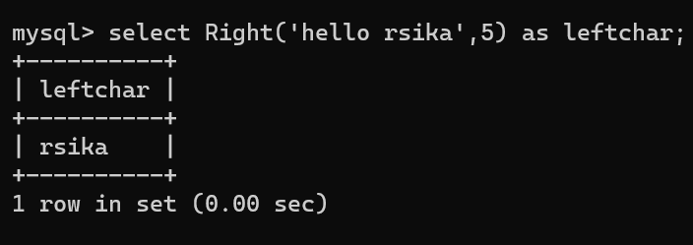

**36.ASCII**

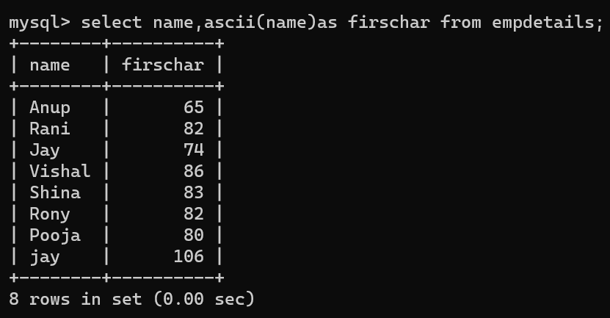

**37 Reverse:-**

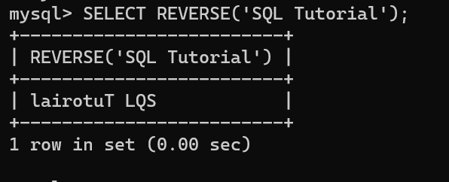

**38.Limit**

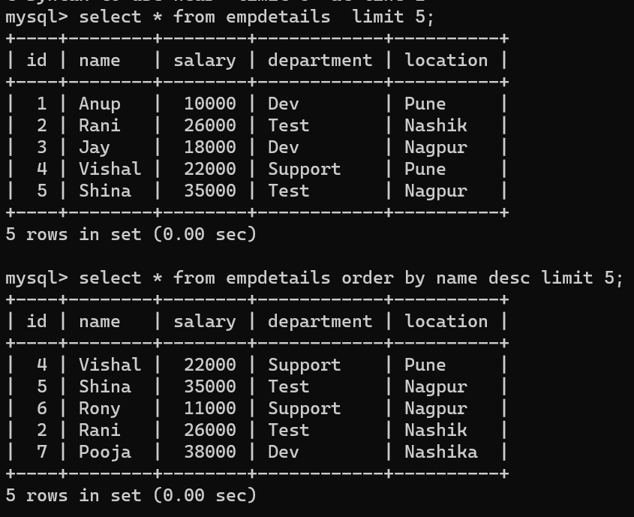

**39.Group by:-**

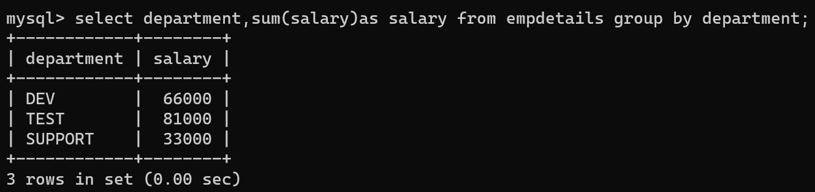

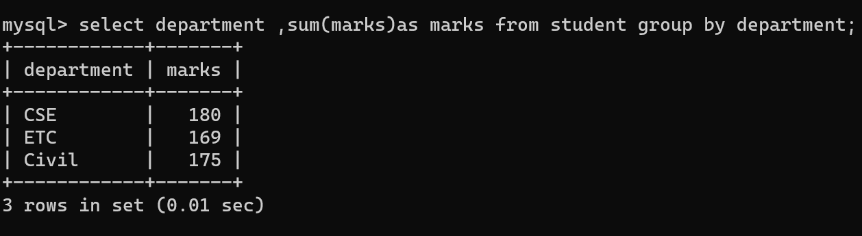

**40.**